A Pareto chart is a type of chart that contains both bars and a line graph, where individual values are represented in descending order by columns, and the cumulative total is represented by the line. In this way, the chart visually depicts which situations are more significant.

# Pre-requisite

Should have a Power BI table with incidents data, one row per incident. Should have the attribute – “category”, against which the pareto would be created. Other attributes like status, created data, etc. can be present but it is not necessary.

# DAX

For the bars, it would be just the Incident count.

Incident Count = CALCULATE(COUNTX(Incidents, 1))

For the line, the calculation would be

Pareto % =  
VAR __CurrentCI = SELECTEDVALUE(Incidents[Configuration Item (CI)]) RETURN  
IF(NOT ISBLANK(__CurrentCI),  
VAR __AllSelectedCI = ALLSELECTED(Incidents[Configuration Item (CI)])  
VAR __CompTable =  
ADDCOLUMNS(  
__AllSelectedCI,  
“@Count”, [Incident Count],  
“@Rank”, RANKX(__AllSelectedCI, [Incident Count])-  
RANKX(__AllSelectedCI, Incidents[Configuration Item (CI)])/10000  
)  
VAR __CurrentCompPos = MAXX(FILTER(__CompTable , Incidents[Configuration Item (CI)] = __CurrentCI),[@Rank])  
VAR __CumCICount = SUMX(FILTER(__CompTable, [@Rank] <= __CurrentCompPos), [@Count])  
VAR __TotalCumCount = CALCULATE([Incident Count], __AllSelectedCI)  
VAR __Result = DIVIDE(__CumCICount, __TotalCumCount)  
RETURN __Result)

Here, the column – “Configuration Item (CI)” is the category column.

When the two measures are used in a column with line chart like

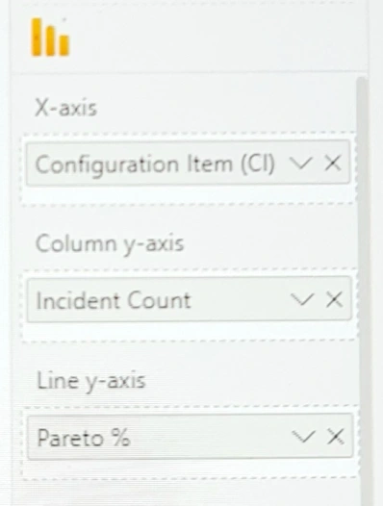

The visual should come up like this

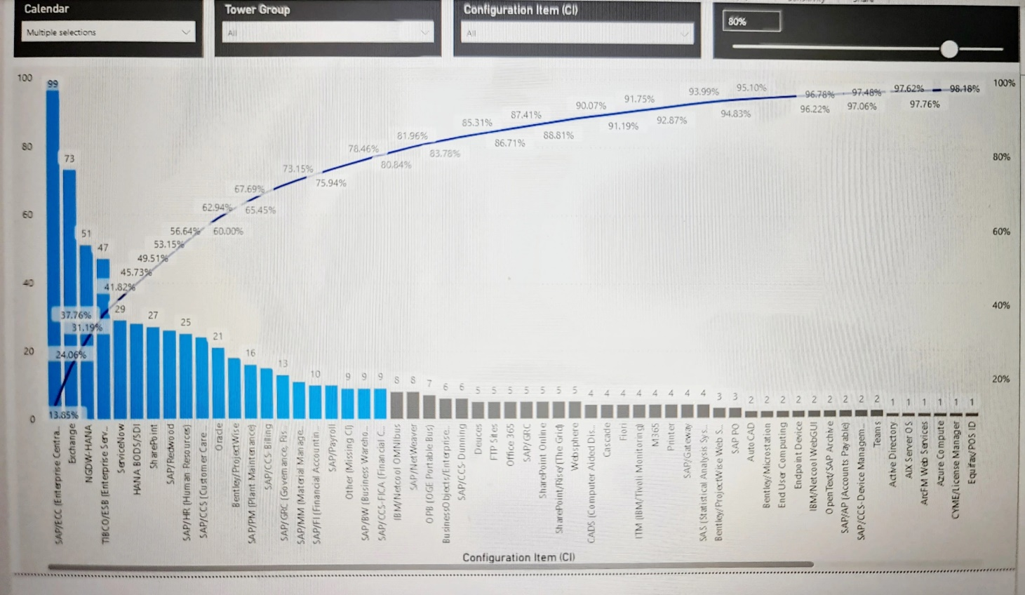

## Nice to Have

Can create a dynamic parameter in the form of a slider visual, which would be used to highlight the columns up to a certain percentage.

Create a parameter using DAX

Pareto Threshold = GENERATESERIES(0.01, 1.01, 0.01)

Add these two additional columns in the generated “parameter table”

Pareto CF = IF([Pareto %]<= [Pareto Threshold Value], “#118DFF”, “#808080”)

Pareto Threshold Value = SELECTEDVALUE(‘Pareto Threshold'[Pareto Threshold], 0.8)

In the end, use conditional formatting over the columns

